Crane Trust Seed Bomb Instructions

Introduction
The Crane Trust is a non-profit organization dedicated to the protection and maintenance of critical habitat for Whooping Cranes, Sandhill Cranes and other migratory birds along the Big Bend Region of the Platte River Valley through sound science, habitat management, community outreach and education. We have a diversity of plant species (over 500 species) that grow on our properties which attract many pollinators including the Monarch Butterfly, Regal Fritillary, and Bumblebees which are all species of concern. Providing high-quality nectar plant resources and host species of milkweeds are critical components to maintaining their habitat and mitigating their decline.

Activity
You will be making seed bombs. The native seeds in these seed bombs are targeted to best support a wide variety of pollinators, including monarch butterflies.
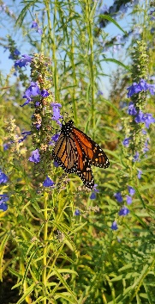
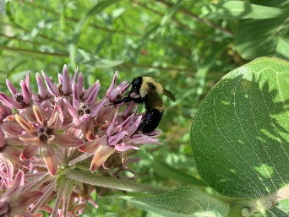
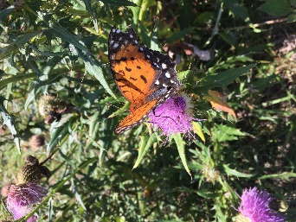
Materials
- Water – approximately 1 gallon
- Clay pellets (provided)
- Soil (provided)
- Native Seed (provided)

Instructions
- Mix enough water to the clay pellets to make clay (approximately 1 gallon)
- Combine the clay, soil, and native seed with your hands and roll into a dime sized ball using the following proportions: 3/5 clay (or 3 parts), 1/5 soil (or 1 part), and 1/5 native seed (or 1 part)
- Take home and let dry
- Find a place that will not be mowed and is not next to an agricultural field (where they will spray insecticides) and throw your seed bomb. Some good locations include: ditches, parks, pastures, or your own native pollinator garden in your backyard!
- Watch as your seeds grow into native prairie plants that will help our pollinators
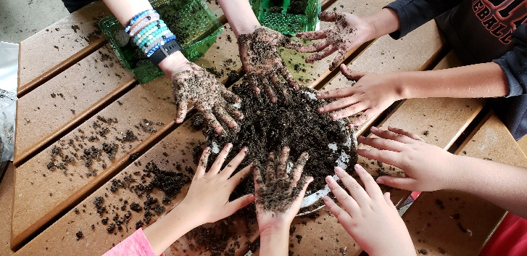
- Rain should provide enough water for your seeds and prairie plants, but an occasional watering may help in the summer.

Thank you!

