Activity: Small Bow, Big Adventure
Grade Level: mid-elementary
Method: Students will create their own miniature bow and arrow from a Popsicle stick, floss, and a q-tip (some prior assembly required).
Materials: Popsicle stick, dental floss (plain), a q-tip, folder, scissors and/or a knife
Objective: Students will develop an understanding of the mechanics behind a bow and arrow and begin to understand the physics involved.
Background: The physics of archery can be a fun and educational way to learn about history, the physics of potential and kinetic energy, and potentially a new life skill. Archery as a sport has been around for over ten thousand years. Some of the earliest known peoples relied on bow and arrows for survival and protection. The Chinese began the port of archery and it is still popular today. The principles of the bow itself can be used to teach many concepts including the transfer of energy. Use the bow example: your back muscles pull on the bow string, which bend the bow limbs (storing potential energy). Upon releasing the string, the energy from the bow limbs is transferred to the string and then to the arrow, and that energy carries the arrow downrange!
Prior to the lesson: Instructor should make sure that there are enough materials for each student to have a popsicle stick, 12in or more of floss, and q-tip and a folder (target). Cut 1/16” slots on both ends and on both sides of the popsicle sticks (pre-notched, see Fig. 1). Place the sticks into a bowl of water 1hr before the lesson, this will allow the rigid sticks to be flexible.
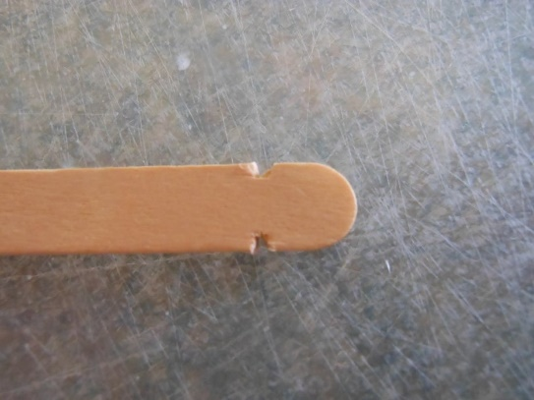
Archery History
Arguably the oldest art still practiced today
Oldest evidence of archery – Egypt around 10,000 BC
Chinese began archery for sport around 1,000 BC (Zhou Dynasty)
Frequently referenced in mythology and folklore (Odysseus, Robin Hood)

Parts of a Bow (see Fig 2.)

Simply – limbs/riser/grip and string (tongue depressor/popsicle stick and floss)
Further – nocking point, arrow rest
Arrow – shaft, nock, tip, fletch/vane
Fig. 2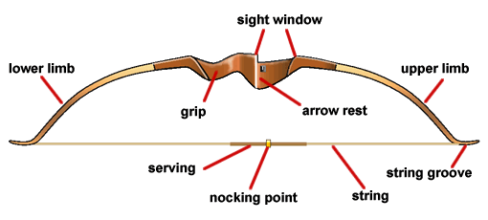*for this lesson, ignore “serving” and “sight window”

Fig. 3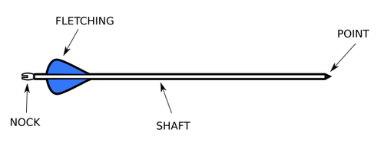

How a Bow Works

Pulling on the string bends the limbs and stores potential energy
Upon releasing the string, the potential energy is converted into kinetic energy and transferred to the arrow
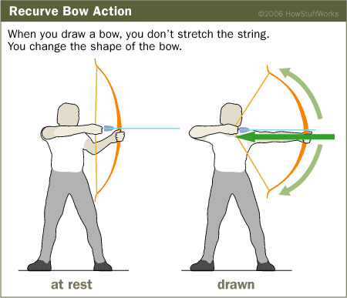

*Safety*
With real archery equipment, always keep a nocked arrow pointed in a safe direction away from other people
Never fire an arrow straight upwards into the air – it eventually comes down with enough force to kill!

Activity

Demonstrate how to string the bow;
Tie knot 1 (slip knot) (it may be worth a YouTube visit here)
Create tension on the bow
Tie knot 2 (wrap 4x around the notch, then square knot)
Demonstrate how to notch the “arrow” to create a nock, and correctly nock it onto the string
*let them shoot for a couple minutes, testing their bows*

Discussion: Discuss how to make a bow shoot further (angle, draw length, draw weight) and more accurately (consistency in materials and technique)

